**Brooklyn torah gazette**

**For parshas terumah 5783**

Volume 7, Issue 24 (Whole Number 331) 4 Adar 5783/ February 25, 2023

**Printed L’illuy nishmas Nechama bas R’ Noach, a”h**

For a free subscription, please forward your request to [***keren18@juno.com***](mailto:keren18@juno.com)

**Rabbi Asher and Henya Federman and children on St. Thomas.**

**To Really Care**

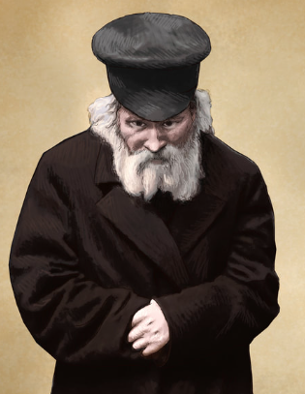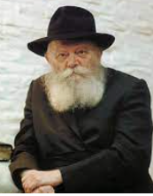

In Poland a decree was once issued against shechita. A delegation of respected Yidden went to beg one of the ministers to annul the decree, but they were unsuccessful. When they returned, they met with the Chofetz Chaim and updated him.

Upon hearing their report, the Chofetz Chaim said to them: "Did any of you faint at the meeting? If it truly mattered, you would have fainted! And then the minister would have seen that the matter was of great importance to you."

Often the Lubavitcher Rebbe would speak out publicly about painful topics which could not be corrected by any of those present. When some people questioned the benefit of such talk, the Rebbe replied, "People say that Az es tut vei, shreit men" – when one is in pain he cries out without considering what he will accomplish thereby. If the issue truly bothered the questioner he wouldn’t have thought of such a question.

*Reprinted from the Parshat Terumah 5783 email of The Weekly Farbrengen*

# Codex Sassoon: World’s Most Expensive Book for Sale

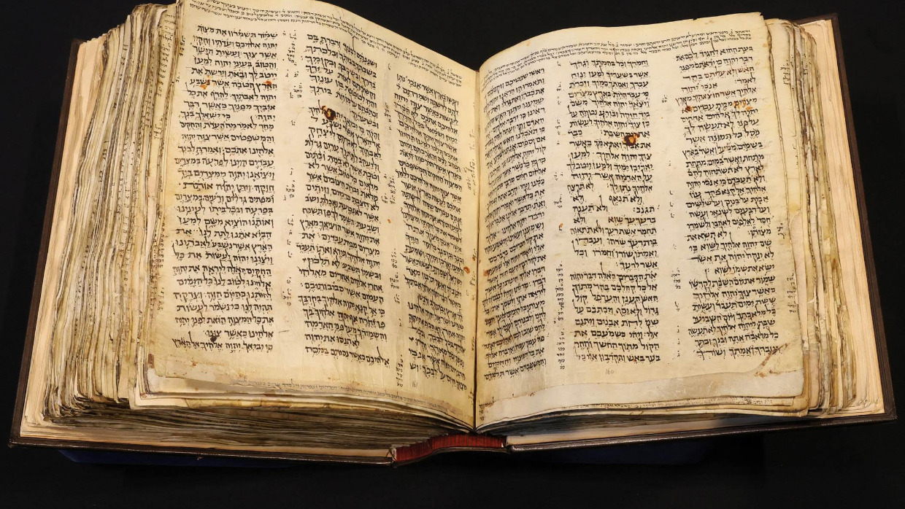

On May 16, 2023 the “earliest most complete” version of the Hebrew Bible, the Codex Sassoon will have a new owner. With a winning bid expected in the range of $30-50 million, the Codex Sassoon may very well become the most expensive book ever sold. What makes it so special?

To appreciate the value of the Codex Sassoon, one must first understand the history of the Hebrew Bible. Since biblical times until the printing press, the sacred books of Judaism were exclusively hand-written on biodegradable materials, such as leather. With the exception of the Dead Sea Scrolls that were partially preserved in clay jars for over 2000 years in the uniquely dry climate of the Judean desert, none of the biblical scrolls from antiquity survived until the present day.

The oldest near-complete witness to the text of the Hebrew Bible, therefore, is the Codex Sassoon that was written in the first-half of the 10th century (think of a “codex” as a fancy word for a hand-written book). Hebrew codices are first attested to in the late 8th century, and there is only one other Hebrew Bible codex from as early as the 10th century —- the famous [Aleppo Codex](https://aish.com/the-scandalous-history-of-the-aleppo-codex/), written around the same time as the Sassoon Codex.

It is unknown in exactly which year either the Sassoon or Aleppo codices were written, because neither scribe recorded a date of completion. The estimate of the “beginning of the 10th century” and possibly “end of the 9th century” for the date of the Codex Sassoon is thus based on subtle changes in the way the Hebrew script developed, indicating its window of completion. Test results of carbon dating of the Codex Sassoon, performed prior to the upcoming auction, confirm a similar range for its completion in the late 9th or early 10th centuries.

*Reprinted from the February 19, 2023 website of aish.com*

Thoughts that Count for the Parsha

Speak to the Children of Israel, that they may bring me an offering (Ex 25:2)

The word “offering” has two meanings: something set aside for a special purpose and that which is picked up and raised. An offering made to G-d achieves both of these objectives. Setting aside one’s money to do a mitzva elevates the actual physical object that is bought with that money, transforming the material into holiness, as it says in Tanya: “G-d gives man corporeality in order to transform it into spirituality.” (Likutei Sichot)

“The fool gives, and the clever man takes,” states the popular expression. What does this refer to? The giving of tzedaka (charity). The fool thinks he is parting with something belonging to him; the clever man realizes that whatever he gives , he actually receives [its reward]. (Rabbi Yisrael of Ruzhin)

***Reprinted from the Parshat Terumah 5782/2022 edition of L’Chaim (Issue #1709)***

**Rav Avigdor Miller on**

**Praying for a Million Dollars**

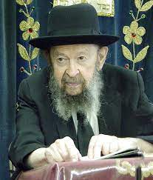

**QUESTION:** **Is there anything wrong with me davening to Hashem that He should give me a million dollars?**

**ANSWER:** It depends what you’ll do with a million dollars. Ordinarily it’s a nuisance to have a million dollars. Once you get a million dollars then your life is no longer a life. You’re a slave to your money. You have to take care of your property. You have no menuchah. A poor man goes to sleep at night and nobody bothers him. A rich man is always on the go.

However, if you want a million dollars in order to build a big yeshivah, then pray for a million dollars, yes. If that’s what you want it for, absolutely.

If you pray for other things, it’s surely good. הרחב פיך means you should open your mouth wide and ask for everything. Who says only a million dollars is good?  Open your mouth and say, “Ribono Shel Olam, help me know a whole mesichta. I would love to know Bava Kama from the beginning to the end.” Wouldn’t that be a glorious thing to know Bava Kama? And maybe Bava Metzia too? Maybe Bava Basra too? Do you know what a happiness it would be if you knew three mesichtas from the beginning to the end? You’re a real millionaire. Nobody could compare to you.

So first pray for one perek. Ask Hashem that He should help you to know one perek perfectly. Then you’ll know another perek and another one and little by little maybe you’ll become a millionaire in Torah.

You should pray to have good children too. Make sure to pray for everything. And if you pray for a million dollars too, it’s no cheit. Only you have to know that in case it happens it’s not such a simple matter. You have to expect a great deal of complications.

*Reprinted from the February 16, 2022 email of Toras Avigdor. Adapted from Tape #E-15 – June 1995*

**The Eternal Legacy of the Shulchan and the “Show Bread”**

**From the Teachings of the Lubavitcher Rebbe**

**Rabbi Menachem Mendel Schneerson, Zt”l**

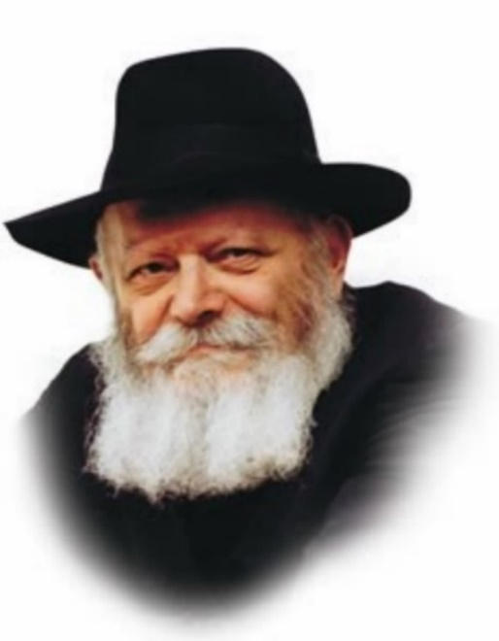

In this week’s Torah portion, Teruma, we read about the Shulchan, the intricate table that was in the Temple. The Shulchan was made of many different pieces. It was made of wood overlaid with gold, and the rest of its parts were made of pure gold. On the Shulchan was a golden trim like a crown around the table. It had a golden framework, with golden trays, that held 12 loaves of bread, called “Show bread.”

This unleavened bread had ends that turned up, and then turned again, so that the two ends faced each other. On the table were two golden spoons filled with Frankincense.

What is the symbolism of the Shulchan? How do we experience the Shulchan in our lives today? According to the Zohar the Shulchan brought blessings of sustenance to the tables of the whole world. The Talmud explains that the crown around the Shulchan is symbolic of royal wealth.

So, the Shulchan brought blessings of sustenance to all and wealth to those who deserved it. How can we harness these blessings in our own lives? By taking a deeper look at the Shulchan and its parts, we find hints that guide us.

First there is a table; the table is the center of the home and therefore is symbolic of the home, the center of Jewish life. Laden with pure gold and surrounded with a royal crown alludes to our dress and sense of dignity. How do we act? Do we see ourselves as ordinary, and dress and act that way? Or do we see ourselves as the royalty we are, the children of the King of Kings, and act accordingly. The way we see ourselves affects the way we act. The way we act, controls the flow of blessings to our homes.

**Recognizing that Our Wealth Comes from G-d**

On the table was the unleavened Show Bread. Bread is symbolic of livelihood. Unleavened symbolizes humility, recognizing that our wealth is from G-d and not arrogantly thinking that it is merely our personal accomplishment. The breads’ ends faced each other, symbolizing love for one’s fellow. The fact that it is one loaf, shows that we are essentially one at our core.

Frankincense is a pleasant-smelling spice, a white resin from a growing tree. A good scent is symbolic of one who does mitzvot. White connotes doing without an ulterior motive. From a growing tree alludes to the need to be constantly growing in mitzvot.

Finally, the Shulchan was placed on the north side, the left side, because in Kabalistic teachings, the Shulchan is connected to the cognitive faculty of Bina, which is on the left. Bina is the ability to take an abstract concept, and develop it into a concrete, understandable and meaningful idea. This is done by breaking down the many parts of the concept and understanding them thoroughly. This refers to the study of Torah. Learning, digesting, developing and finally bringing it down into the concrete, making it accessible to all.

This, in essence, is the Jewish home. A royal abode, a place of dignity, humility, and love. A place of Torah and mitzvot. A place where G-d wants to be and gives His blessings.

Adapted by Rabbi Yitzi Hurwitz from the teachings of the Lubavitcher Rebbe, yitzihurwitz.blogspot.com. Rabbi Hurwitz, who is battling ALS, and his wife Dina, are emissaries of the Rebbe in Temecula, Ca.

***Reprinted from the Parshat Terumah 5782/2022 edition of L’Chaim (Issue #1709) Adapted from the teachings of the Lubavitcher Rebbe, zt”l.***

**Rabbi Berel Wein on**

**Parshas Terumah 5783**

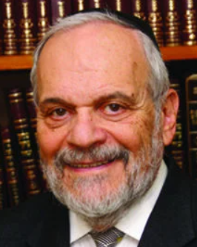

The parsha of Terumah follows those of Mishpatim and Yitro. In parshat Yitro we experienced the moment of the revelation at Mount Sinai and the granting of the Torah to the Jewish people. In parshat Mishpatim the Torah began to fill in the details of Jewish law and life, especially as they relate to human and societal behavior and the standards of such behavior that the Torah wishes us to uphold.

In this week’s parsha of Terumah the Torah presents another challenge to human behavior – wealth, money, charity and the ability to give away what one may deem to be his or hers. The Torah demands from us the ability to donate to others, to give to great causes, to the public welfare and to be able to share with others our material possessions.

The rabbis of the Talmud stated that this is one of the major identity tests of life. Miserliness, a bad eye and an unwillingness to be able to contribute to others in need are held to be violations of Torah principles and morals. The Torah at Sinai instructed us not to steal, not to take from others what belongs to them without their explicit consent. Now the Torah raises the bar and asks us to be able to give away what we deem to be ours to others less fortunate than us or to national and religious causes that benefit us all.

All of this is implied in the request for donations to help build the holy Mishkan/Tabernacle. The L-rd could have provided us with a ready built spanking new Mishkan/Tabernacle on His own. Instead, He challenged us then and in every continuing generation of Jewish life to build a Mishkan/Tabernacle on our own and from our own resources. And that requires a proper view of our own wealth and what we do with it.

My beloved Talmud rebbe taught me over sixty years ago how to read the daily newspaper – how to filter out the golden nuggets of life and morality from the overwhelming amount of dross that fills the pages of all of our newspapers. There was an item in the newspaper last week about a baseball pitcher who gave up a guaranteed salary of twelve million dollars for 2011 and retired from the game because he felt in all honesty that he could no longer pitch effectively and did not wish to be paid for essentially doing nothing.

This naturally goes against the grain of the vast majority of professional athletes whose greed and avarice is so well known. That is why it made news – it was a man bites dog story. But it indicated to me that the lesson of parshat Terumah still lives in the human heart.

To be able to walk away from money not honestly earned is a Torah value. And to share and give of our wealth to others and to the building of society, to Torah education and a national home for Jews, is also a supreme Torah value.

We have to build our own Mishkan/Tabernacle constantly in every generation. The Torah’s attitude towards the sharing of our wealth is the key to such a form of Mishkan/Tabernacle building.

*Reprinted from this week’s website of rabbiwein.com*

**Stay Young**

**By Rabbi Yaakov Bender**

*And you shall make two Keruvim (25:18).*

Rashi says: Each one had the face of a child. While other Rishonim disagree, Rashi teaches us that the Keruvim were made with the faces of children. The Gemara bases this opinion on the word ke-ravya, like a child (Chagigah 13a). What is the significance of this?

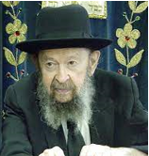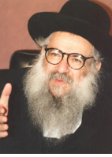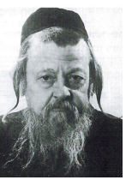

**Rav Avigdor Miller, Rav Shomo Freifeld and the Tchebiner Rav**

The week after I became a chassan, I went to spend Shabbos at the home of my parents-in-law. I davened with them at the shul led by Rav Avigdor Miller. He asked this question, wondering why the inspiration would come from the images of children. “Wouldn’t we think that we can gain more chizuk from a picture of Rav Moshe [Feinstein] or Rav Yaakov [Kamenetsky],” he asked, using the example of the gedolim of the time, “than from that of a child?”

Rav Miller explained that the catalyst for avodah, the motivation to serve Hashem properly, comes from a child. Chassidim relate in the name of the Maggid of Mezritch that we can learn three things from a child: When he wants something, he wails until he gets it. He keeps moving, never idle. And finally, if his basic needs are met, he is in a good mood.

Yehoshua bin Nun is referred to as a na’ar (Shemos 33:11), a lad, because of his youthful energy, his devotion and determination to hear and internalize every bit of Torah from Moshe Rabbeinu.

Rav Shlomo Freifeld was once trying to get a point across to a group of talmidim and he felt like they were too cynical, too reluctant to hear his plea for change. He grabbed his own beard and said, “You know, I have a gray beard, but I feel like I am the youngest person in this room!”

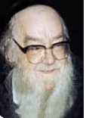

**Rav Shalom Schwadron**

Rav Shalom Schwadron would recall walking by the Tchebiner Yeshivah one day and hearing a young man learning with the Tchebiner Rav, Rav Dov Berish Weidenfeld. The younger chavrusa was speaking out the Gemara, step by step, with the enthusiasm of a rebbi teaching new talmidim, and Rav Shalom was intrigued.

He went to see who was learning with the rav and was astounded to see the Tchebiner Rav learning by himself, reading the Gemara with the excitement of a young bachur. This was the point of the Keruvim, said Rav Miller. To remind us, to inspire us, to motivate us to be young again.

On the pasuk here, the Baal HaTurim writes that the Keruvim appeared as children, and then connects this with the pasuk in which the Ribbono Shel Olam speaks of His love for Klal Yisrael, saying, “Ki naar Yisroel va’ohaveihu – When Yisrael was young, I loved him” (Hoshea 11:1). Hakadosh Baruch Hu appreciates us for this middah of “youth” — and youth has nothing to do with physical age. In the holiest place in the world, the center of avodah, stands a reminder to us to stay young.

*Reprinted from the Parshas Terumah 5783 edition of At the ArtScroll Shabbos Table. Excerpted from the ArtScroll book – Rav Yaakov Bender on the Chumash*.

**Tied to the Peg**

**By Rabbi Eliezer Abish**

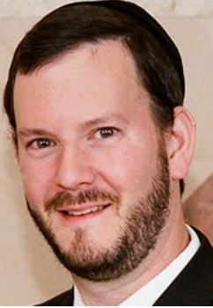

In Parshas Terumah, we learn about the building of the Mishkan, and at the end of the Parsha, the Torah tells us how to build the walls around it. The Torah tells us that all the pegs should be made out of cooper. Rashi explains that these pegs, which essentially were large nails, were for the purpose to tie the cord around the peg. This was so the wind would not lift it when it blew.

Rashi then says, “I don’t know if these pegs are stuck into the ground, or there is just a rope tied around the head of the peg and because it is so heavy, it weights it down and the wind cannot blow it. But I say that because of their name, pegs, they are riven into the ground.” The commentarieswonder that since when does Rashi mention his thoughts process towards reaching a conclusion and sound like a Gemara. Rashi never does that.

**How to be a True Eved Hashem**

Rav Moshe Feinstein tells us a very interesting thing. We are building a Mishkan, which is how we feel Hashem’s presence in earth. Rashi was wondering how we can stay tied to Hashem. Rashi is wondering if it is enough to just take the peg and tie the cords around it, or perhaps that is not enough. You also need to drive the peg into the ground. Rashi says that you also need to drive the peg into the ground.

With this, Rav Moshe says that to be an eved Hashem, a person cannot just work on his relationship with Hashem. While that is needed, it is up to us how much of a relationship we want. But we also must be tied to a community, to a rebbe, yeshiva, shul, chesed organization, parents, fellow Jews. It is not enough to just make sure your relationship is strong. You need to make sure your relationship to Klal Yisroel is also pushed into the ground.

There was a fellow who used to play football, and he made it to his high school team, and one time the team lost by a few points. In the locker room the quarterback was very excited, because he threw a lot of completions and he did well. The coach pulled him aside and asked why he was so happy. He said, “What do you mean? Look how many completions I had!” The coach told him a very important rule. “You play for the front of your jersey; not the back.”

The lesson is that you are not for yourself, but for the rest of the people. It is not enough to just be tied to the peg; the peg has to be knocked into the ground as well. And that is the only way we can stay secure.

*Reprinted from Parashat Teruma 5782 edition of The TorahAnyTimes Newsletter.*

**Great and Grand or**

**Small and Simple?**

**By Rabbi** [**Yossy Goldman**](https://www.chabad.org/search/keyword_cdo/kid/1351/jewish/Goldman-Yossy.htm)

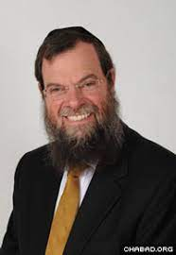

Can human beings really build a House for G‑d? King Solomon himself questioned this when he built the very first Holy Temple in Jerusalem. “The heavens, even the highest heaven, cannot contain you. How much less this house I have built!”[1](javascript:doFootnote('1a5824649');)

And yet, the Almighty Himself instructs us to do just that: “And they shall make Me a Sanctuary and I will dwell among them.”[2](javascript:doFootnote('2a5824649');) How are we to understand that the Infinite Creator can be contained in a physical house built by finite men and women?

Let’s do what Jews have always done and answer this question with another one.

Why is the Sanctuary described in this week’s reading so small? One would imagine that the very first House of [G‑d](https://www.chabad.org/library/article_cdo/aid/433240/jewish/God.htm) would have been spectacular. Yes, it was a portable temple which needed to be erected and dismantled regularly over 40 years in the wilderness, but still. It was smaller than a starter home! A roof of animal skins, held together with bolts and nuts, hooks, pegs and sockets. And while it was, admittedly, covered in gold, it was a far cry from the magnificent palaces and citadels of others.

The moral of the story? G‑d does not require spectacular spires or museums to house His holy presence. Where is He found? In the nitty-gritty nuts and bolts of a simple synagogue.

Back in 1983, I was the founding rabbi of the Torah Academy Shul in Johannesburg. The school had purchased a large tract of land which had previously housed a Catholic institution and our new synagogue was going to be situated in what was previously the chapel. Many of my congregants asked whether we needed to do any particular ceremony before we could move in.

At the time, Rabbi Betzalel Zolty, a respected halachic authority and former Chief Rabbi of [Jerusalem](https://www.chabad.org/library/article_cdo/aid/4246466/jewish/Jerusalem.htm) was visiting our community, so I put the question to him. “Do we need to do anything special to convert the chapel into a shul?”

His sharp and simple reply? “Make a *minyan*!”

A [*minyan*](https://www.chabad.org/library/article_cdo/aid/543104/jewish/Why-Are-Ten-Men-Needed-for-a-Minyan.htm), a quorum of Jews praying together, is all that was needed to inaugurate and consecrate our synagogue.

And that is exactly how we invite G‑d into our synagogues and make Him feel welcome. Sometimes we think we must conquer the cosmos to bring heaven down to earth, but all we need to do is make a simple *minyan*.

You don’t have to solve the Middle-East crisis, but you can say a prayer for Israel. You don’t need to become a rabbi, but you could attend a weekly [Torah](https://www.chabad.org/library/article_cdo/aid/1426382/jewish/Torah.htm) class. You needn’t give away billions like Bill Gates and Warren Buffet, but you can give a little more tzedakah than feels comfortable. And you’re not expected to settle every family feud, but you could smile at your difficult brother-in-law once in a while.

The Alter Rebbe, founder of Chabad chassidism, once said:

Avodah*—true service of G‑d—does not imply, as some think, altogether erroneously, that one must pulverize mountains and shatter boulders, or turn the whole world upside down.*

*No!*

*The absolute truth is that any act is perfectly satisfactory when performed with authenticity and true intent. A blessing pronounced with concentration, a word of prayer as it should be with awareness of “before Whom you stand,” a passage in*Chumash*while being aware that it is the word of G‑d, a verse of Psalms, an act of kindness and compassion expressed in befriending another person with love and affection.*

It is precisely the small things that build the Sanctuary of G‑d and bring heaven down to earth. G‑d is not looking for grandeur or opulence, but the ordinary acts of sanctity and spirituality, goodness and kindness that make our world a better, more G‑dly place—a holy house where He feels most comfortable.

Let us make Him our own little sanctuaries and He will dwell among us.

**FOOTNOTES**

[1.](https://www.chabad.org/parshah/article_cdo/aid/5824649/jewish/Great-and-Grand-or-Small-and-Simple.htm" \l "footnoteRef1a5824649) 1 [Kings 8:27](https://www.chabad.org/15892#v27).

[2.](https://www.chabad.org/parshah/article_cdo/aid/5824649/jewish/Great-and-Grand-or-Small-and-Simple.htm" \l "footnoteRef2a5824649) [Exodus 25:8](https://www.chabad.org/9886#v8).

*Reprinted from the Parsha Terumah 5783 website of Chabad.Org Magazine.*

**More Thoughts that**

**Count for the Parsha**

*Of a talent of pure gold shall it be made* (Ex. 25:39)

A person’s purpose in life is to illuminate his surroundings with the light of Torah and mitzvot. This responsibility holds true no matter what the individual’s circumstances or mood may be. The numerical equivalent of the Hebrew word for talent, “kikar,” is 140 – the same as the numerical equivalent of “mar” (bitter), and “ram” (lofty). No matter what our situation, our task remains the same. (the Previous Lubavitcher Rebbe – Rabbi Yosef Yitzchak Schneersohn)

Two and one-half cubits its length, and a cubit and a half its breadth, and a cubit and a half its height (Ex. 25:10)

The ark was measured in fractions, not whole numbers, teaching us that to achieve spiritual growth, one must first “break down” and shatter one’s negative characteristics and bad habits. (Sefer Hamamarim U’Kuntreisim)

*Reprinted from the Parshat Terumah 5782/2022 edition of L’Chaim (Issue #1709)*